Final Report to the North Pacific Fishery Management Council
For the
Bering Sea and Aleutian Islands Management Area (BSAI) Groundfish Fishery Exempted Fishing Permit #06-04.

Karl Haflinger, Sea State Inc. - Project Manager
John Gruver, AFA Catcher Vessel Intercooperative - Project Manager and Permit Holder

Kevin Duffy, Pollock Conservation Cooperative - Permit Holder

This draft report is to the North Pacific Fishery Management Council and covers the Bering Sea and Aleutian Islands Management Area (BSAI) Groundfish Fishery Exempted Fishing Permit #06-04. During the course of the fishery, the pollock Intercoop closed 25 different areas to fishing, based on high bycatch rates for chinook or chum salmon, experienced by vessels working in the area. Maps of the closures are shown in Appendix 1. Under the terms of the EFP, applicants are to submit to the Council a report analyzing:

- Number of salmon taken by species during the experiment
- Estimated number of salmon avoided as demonstrated by the movement of fishing effort away from salmon hot-spots.
- A list of each vessel’s number of appearances on the weekly dirty 20 lists for both salmon species
- A compliance/enforcement report that will include the results of an external audit designed to evaluate the accuracy of the approach used by Sea State to monitor compliance with the agreement, and a report on the effectiveness of enforcement measures stipulated under the ICA in cases of non-compliance. Examination of a randomly selected subset of vessel/days representing 10% of the catch during the experiment will be sued as the basis of the audit.
A final report which will include an additional section on compliance/enforcement will be presented to the Council in February and will include the results of an external audit to be performed by Alaska Biological Research (ABR Inc).

Number of salmon taken by species during the experiment:

The EFP ran from 8/1 through the end of the pollock fishery. For the sake of comparison we have included catch and bycatch running back to 2000. These data are compiled from plant landing information for catcher vessels delivering to shoreside processors, and observer data for mothership catcher vessels and catcher-processors. The “other salmon” category includes all non-chinook salmon. Observer data for both offshore and shoreside deliveries show that only very small numbers of salmon other than chum in this category (152 unidentified, 31 pinks, and 5 silvers for the 2006B season EFP).

Table 1. Catch and bycatch of pollock and salmon in the directed pollock fishery for full year and from August 1 through October 31, 2000 – 2006 (includes CDQ harvest).
 | 8/1 of year onward |  |  | Full year
Year | Pollock (mt) | Chinook (N) | Other sal (N) | Pollock (mt) | Chinook (N) | Other sal (N)
2006 | 546,499 | 21,244 | 123,266 | 1,453,037 | 80,844 | 277,996
2005 | 495,544 | 42,581 | 333,401 | 1,451,268 | 68,038 | 638,570
2004 | 490,934 | 27,889 | 380,652 | 1,437,776 | 50,714 | 428,793
2003 | 526,149 | 13,083 | 156,909 | 1,453,525 | 44,425 | 174,070
2002 | 558,510 | 12,996 | 78,407 | 1,437,789 | 33,786 | 83,833
2001 | 601,151 | 13,546 | 47,061 | 1,351,956 | 30,163 | 53,255
2000 | 562,660 | 1,618 | 40,771 | 1,080,734 | 5,245 | 57,541

Evaluation of salmon savings.

The evaluation of the number of salmon saved by the IC program is based on tracking vessels that fished in a closed area before it closed, and then comparing their subsequent bycatch to see if it was lower than expected if the area had not closed. The procedure is as follows:

- Extract all observer data for haul locations falling inside a closure area, for a 5 day period preceding the closure. For shoreside catcher vessels, aggregate the hauls that have the same “start fishing date” so that hauls with the same bycatch rate are not artificially repeated. As an example, if 2 hauls from the same catcher vessel trip show up in the closed area, they will have the same bycatch rate because observers pro-rate bycatch evenly across all hauls. Consider them a single observation with a value equal to the sum of the two hauls’ pollock and salmon.
- Consider all of independent offshore sector (C/P and mothership) hauls, and combined “trip-level” hauls to be estimates of the bycatch ratio 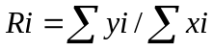, where y are counts of chinook or chum salmon, and x is the pollock catch from individual hauls (offshore sector) or grouped, same-trip hauls (shoreside), and i indicates a separate closure.
- Extract the same haul or “grouped” haul information, for the same vessels, for the next 5 days. Their associated bycatch is available from either observer or plant delivery information. Compute their expected bycatch had they been able to stay and fish inside the now-closed area, by summing the pollock catch of all vessels in this category, and multiplying this summed pollock catch by the matching bycatch ration, Ri above.
- Compute the standard error of this estimated Y (overall salmon bycatch if vessels had stayed in the area and fished with bycatch rate R) treating R as a ratio estimator (Snedecor and Cochran, Statistical Methods, 8th Edition, p 452).

The three maps below illustrate this procedure for the chinook closure of 9/22/06. Figure 1 shows the chinook closure that began on 9/22/06, and includes the locations of observed hauls taken in that area during the 5 day period preceding the closure. After the closure, vessels who had been in that closure area (i.e. those whose hauls are shown in Figure 1) either moved a small distance to the southwest, or made large moves to the northwest (Figures 2 and 3). Lower chinook rates were found in all of the new fishing areas.

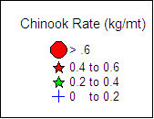

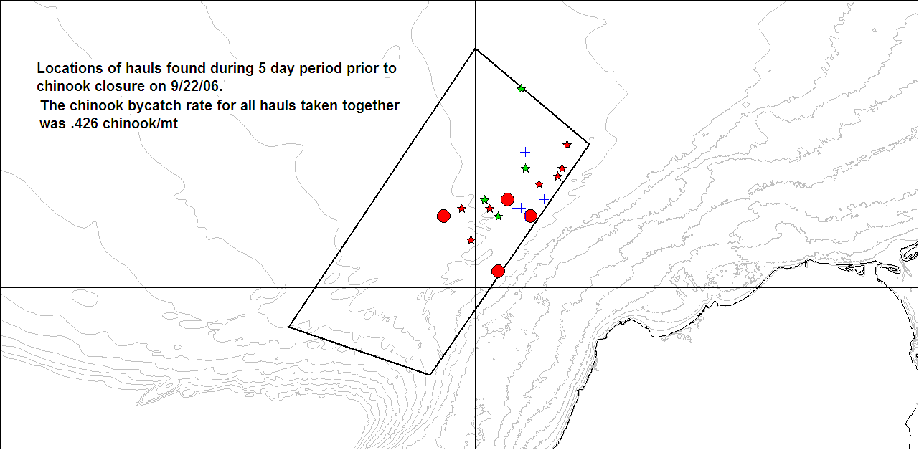
Figure 1. Hauls selected for analysis of chinook closure on 9/22

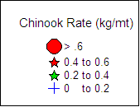
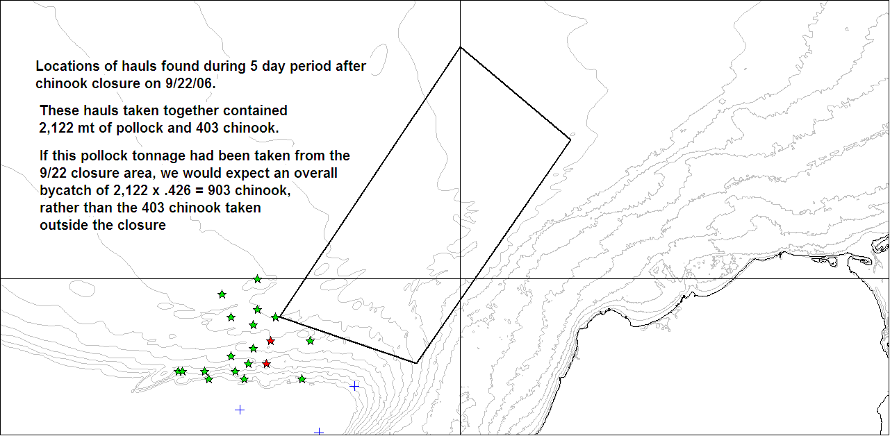
Figure 2. View at the same scale as above of five day fishing activity for vessels in the first map (Fig 2) showing positions that led to a reduction from an expected chinook take of 903 to 403 actual (i.e. counted by observers from the haul positions shown).

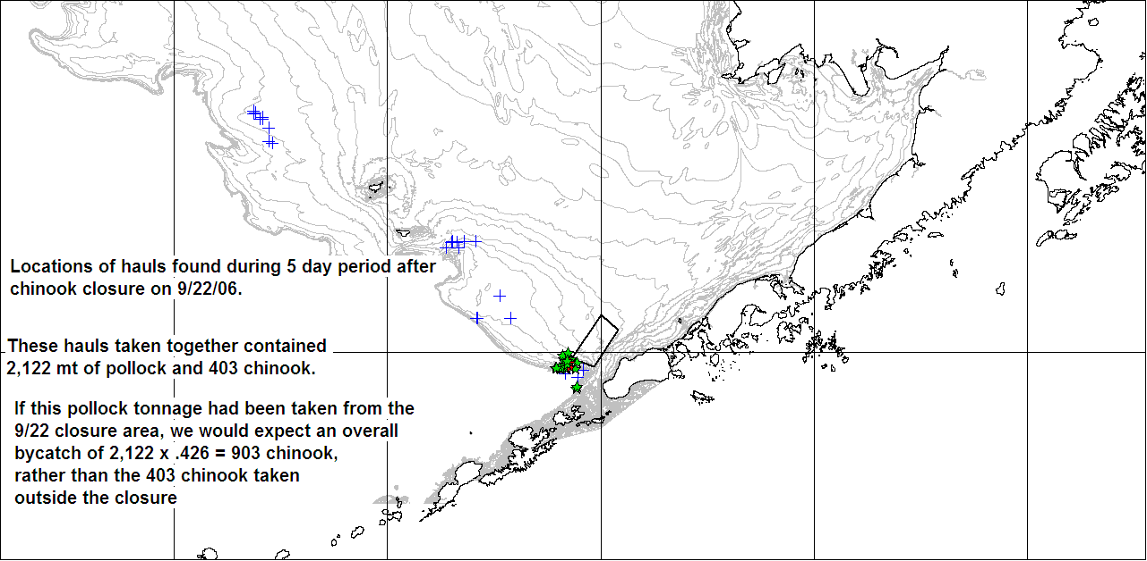
Figure 3. Full view of all hauls from boats in map 1-A for the 5 day period after the start of the 9/22 closure

The results from these calculations are shown in tables below. For the period 8/1/06 – 10/31/06 there were 25 closures that could be evaluated, and of these 24 closures for which observer data could be found from vessels fishing inside the areas before they closed. (Note that closures may be based on deliveries from catcher vessels that did not carry observers, and thus there could be closures for which there is no observer information prior to the closure). Of these 24, we were able to find 20 that also had post-closure observer information for vessels that fished inside prior to the closure (that is, we had observer information for boats both before and after the closure). Again, shoreside catcher vessels may have had an observer aboard before the closure but then delivered and come back to the grounds without an observer, thus removing the boat from before/after comparisons. Finally, two of the closures with both prior and subsequent observer information were limited to a sample size of one tow (or one combined tow for shoreside CVs with aggregated tow data), and for those closures estimates of variance about R could not be calculated.

Table 2 below is a summary of the results for both chinook and salmon closures (Tables 4 and 5 at the end of this section show the underlying data, by closure, with associated standard errors). The results indicate that for the approximately 40,000 mt of observed groundfish associated with boats that fished inside areas before they were closed, and that also had observers after closures, 1,692 chinook and 62,732 chum were avoided. These numbers represent reductions of 20% and 64% respectively for these species, for the vessels analyzed. Chinook closures appear to have had an associated significant effect in lowering chum bycatch, while chum closures appear to have a negative, but likely insignificant, effect in lowering chinook bycatch.

Table 2. Summary of Chinook and chum closure effectiveness
 | Chinook closures | Chum closures | All closures
Pollock catch (after closure) | 24,007 | 23,049 | 47,057
Actual chinook bycatch | 6,105 | 565 | 6,670
Expected chinook bycatch | 7,641 | 468 | 8,109
Chinook savings | 1,537 | -97 | 1,439
% reduction | 20% | -21% | 18%
Actual chum bycatch | 7,429 | 28,462 | 35,891
Expected chum bycatch | 22,849 | 78,342 | 101,191
Chum savings | 15,419 | 49,880 | 65,299
% reduction | 67% | 64% | 65%

It should be emphasized that the overall numbers of salmon saved are for the group of vessels with observers that could be tracked by fishing immediately prior to the closure in the closure area, and then just after the area closed. There are other boats whose activities are affected by closures but that don’t fall into this analysis. These include vessels without observers and vessels that avoided the closure areas entirely and chose instead to fish to the northwest, where salmon are rarely encountered. For shoreside catcher vessels in particular, the uncertainty over whether or not the grounds they are fishing will be closed is significant. These catcher vessels often have only two days time in which to fill their vessels and if in the middle of a trip their grounds are taken away by a salmon closure, they may eventually be forced to return to shore with only a partial load. We cannot quantify the weight of this factor in captain’s decision to fish away from the closure areas, but have had the concern reported to us and note that it is another avenue in which salmon closures reduce bycatch, but one that cannot be analyzed with the methods at hand. Figure 4 below shows haul locations based on observer data for shoreside catcher vessels after August 1. The set of hauls to the west of 171 W (i.e. those up to the northwest of the Pribilof Islands) represent 98,000 mt of pollock, while those to the east represent 82,000 mt.

Figure 4. Catcher vessel haul locations after 8/1/06, based on observer data.
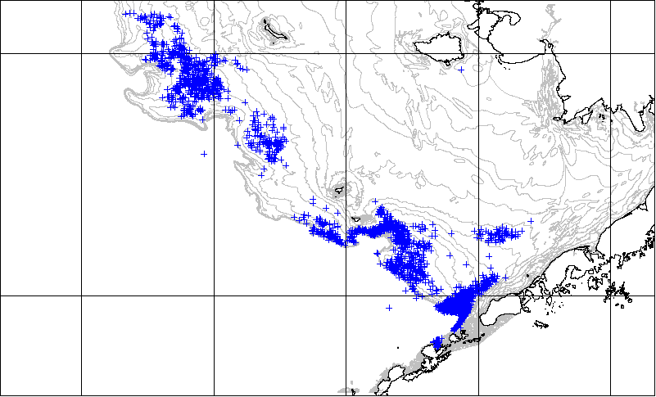

Finally, Figure 5 shows bycatch rates for various pollock fishing areas from 9/5 onward, which is when most chinook were encountered (see Figure 6 below for chinook bycatch timing diagram). The EFP closures were concentrated in the Unimak Pass area (known as the horseshoe) and extending up along Unimak Island. Their overall effect was to keep the bycatch rate for this area down to .26. Most of the main fishing grounds south of Pribilof canyon showed similar bycatch rates. An area at the head of Pribilof Canyon had somewhat lower rates, but was still not free of chinook salmon. The only areas that appeared to be almost completely clean were up near Zhemchug canyon (R = .01), which is out of the reach of many shoreside catcher vessels, and an area further up in Bristol Bay (R = .03) which is much closer, but which rarely has fishable concentrations of pollock in the B season. It is apparent that, for 2006 at least, no closures short of a complete cessation of pollock fishing south of the Pribilof Islands would have reduced overall bycatch rates south of the Pribilofs to much below .25 salmon per mt. Individual closure bycatch rates listed in Table 3 below show that the closure areas generally had bycatch rates higher than the .25 level that appeared widespread south of the Pribilofs during the 2006B season. This indicates that the procedures used to identify hotspots successfully result in creating closure areas that effectively reduce salmon bycatch in the Bering Sea pollock fishery.

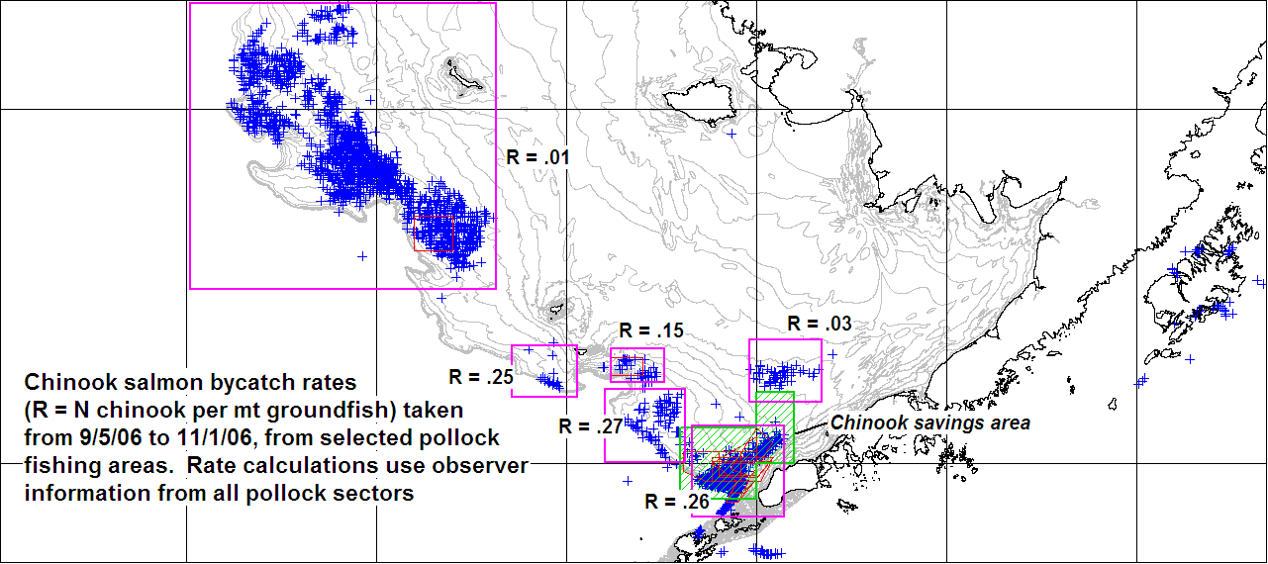
Figure 5. Chinook bycatch rates for major pollock grounds, 9/5/06 – 11/1/06. Rates were computed from all observer hauls that occurred in purple blocks. Thin red shapes indicate EFP chinook and chum closures from 9/5 onward. Green shading indicates the old Chinook Salmon Savings Area.

Table 3. Bycatch rates found within closure areas for the 5 day interval preceding the closure.
ClosureType | Date | Chinook rate (N/mt) | Chum rate (N/mt)
Chum | 80406 | 0.00 | 4.08
Chum | 80406 | 0.02 | 3.99
Chum | 80806 | 0.01 | 4.33
Chinook | 81106 | 0.09 | 15.98
Chum | 81506 | 0.01 | 2.42
Chum | 81806 | 0.01 | 3.55
Chum | 82206 | 0.02 | 8.16
Chum | 82506 | 0.03 | 11.50
Chinook | 90106 | 0.08 | 0.61
Chum | 90806 | 0.17 | 0.32
Chum | 91206 | 0.33 | 0.00
Chinook | 91506 | 0.33 | 0.44
Chinook | 91906 | 0.32 | 0.04
Chinook | 92206 | 0.43 | 0.44
Chinook | 92606 | 0.22 | 0.38
Chinook | 92906 | 0.33 | 0.34
Chinook | 100306 | 0.14 | 0.02
Chinook | 100606 | 0.32 | 0.52
Chinook | 101006 | 0.17 | 0.39
Chum | 101006 | 1.09 | 23.64
Chinook | 101306 | 0.43 | 0.17
Chinook | 101706 | 0.33 | 0.13
Chinook | 102006 | 0.31 | 0.14
Chinook | 102406 | 0.34 | 0.16

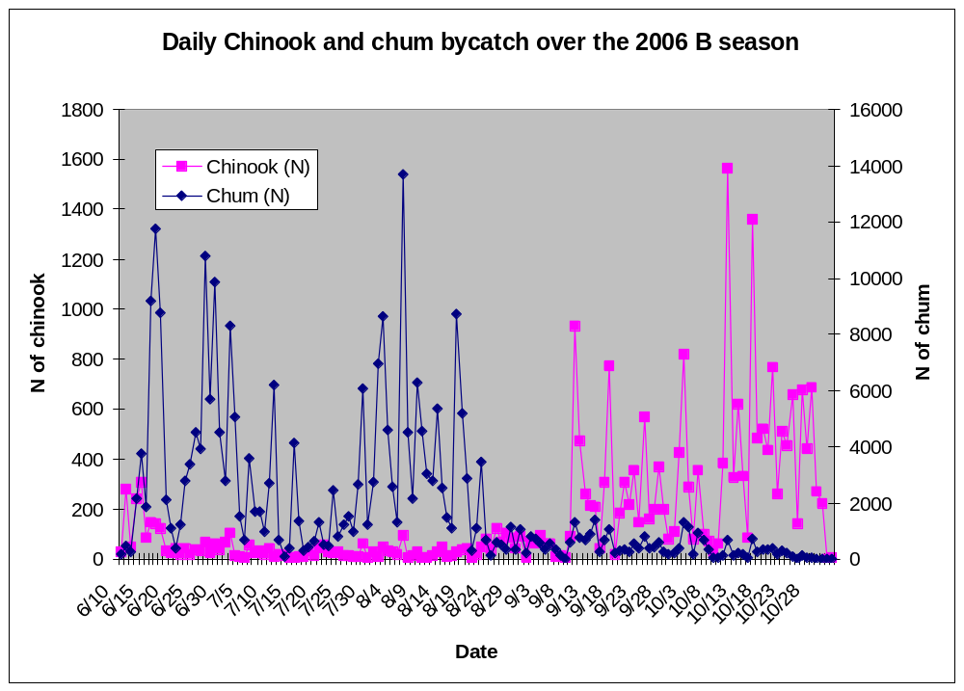Figure 6. Timing of chinook and chum bycatch during the 2006 B season

Table 4. Chinook and chum salmon closure effectiveness, by chinook closure
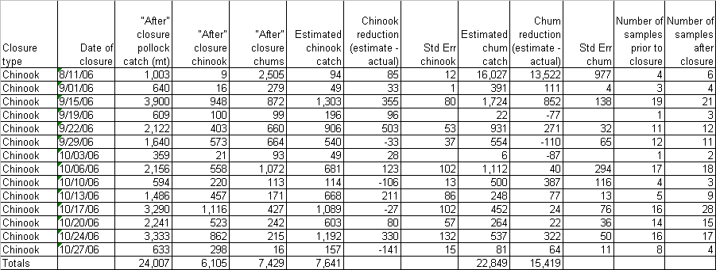

Table 5. Chinook and chum salmon closure effectiveness, by chum closure
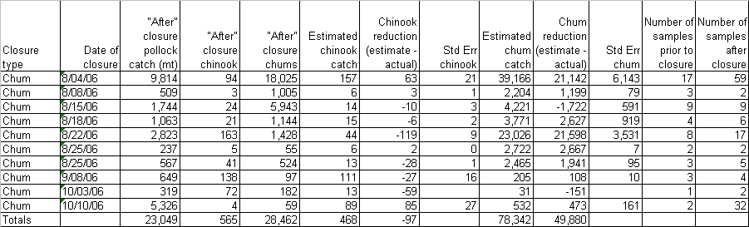

Compliance/ Enforcement

Compliance with the IC salmon closures was examined by analyzing the VMS records of vessels fishing under the EFP. The process involved the following steps:

- For 100% observer coverage vessels and for 30% coverage vessels when observers were present, extract all VMS points from the times that vessels were towing.
- For 30% observed boats when observers were absent, extract all VMS points for each fishing trip, from the day fishing commenced up to and including the day of delivery, as determined from shoreside landing reports.
- Combine both sets of data and then extract those points that fell within closure areas during the time that closures were in effect.
- Examine all points that fell into the result set from step 3 above. If points were from a vessel that had fishing privileges based on tier structure, no violation occurred. If points were from a vessel that was on a tow according to observer data, a notice of apparent violation was issued. If points were clearly from the track of a vessel transiting the area, then no violation occurred. If the points were not clearly from a transiting vessel, logbook pages were requested. Finally, if logbook pages indicated that the point occurred while a vessel was towing, then a notice of apparent violation was issued.

There was very little “judgment” in the process described above. Although we did in many cases decide that a vessel was not in violation based on the decision that the vessel was simply transiting the area, the critiera for transit was that the vessel be basically moving in a straight line at speeds higher than towing speeds (approximately 5 kts). This activity is very apparent on inspection of vessel tracks (see maps below).

The VMS inspection produced 16 apparent compliance violations. The Intercoop agreement specifies the following procedure once apparent compliance violations are found.

a. Sea State shall monitor the fishing activities of all Coops’ members’ vessels, and shall promptly report all apparent Savings Area violations to all Coops. Upon receiving notice of an apparent violation from Sea State, the Board of Directors of the Coop to which the vessel belongs shall have sixty (60) days to take action in connection with the apparent violation, and to provide a report of the action taken and a copy of the record supporting that action to all other Coops. If the vessel’s Coop Board of Directors fails to take action that is consistent with the terms and conditions of this Agreement within such 60 day time period, or fails to provide a report of the action taken and the supporting record to all other Coops within such 60 day period, then Sea State and/or UCB shall provide each other Coop, the CDQ Groups, the Association of Village Council Presidents (“AVCP”), Bering Sea Fishermen’s Association (“BSFA”), Tanana Chiefs’ Conference (“TCC”) and Yukon River Drainage Fishermen’s Association (“YRDFA”) with notice to that effect, and each of such parties shall have standing to pursue Savings Area closure enforcement or penalty actions equivalent to such Coop’s own rights with respect to its members.

The coops to which the apparent violations were sent have until February 9, 2007 to respond to 11 of the violations, and April 5, 2007 for 5 of the violations. The different time period for the last of the violations resulted from late requests for vessel logbooks that could not be fulfilled until crews came back to the boats for the start of the 2007 ‘A’ season.

ABR Inc, and environmental consulting firm in Fairbanks, Alaska was contracted to perform an audit of Sea State compliance monitoring results. A report from this contract will be submitted to the Council at the February 2007 meeting.

Dirty 20 list appearances

Number of weeks each vessel was on the chinook dirty 20 list
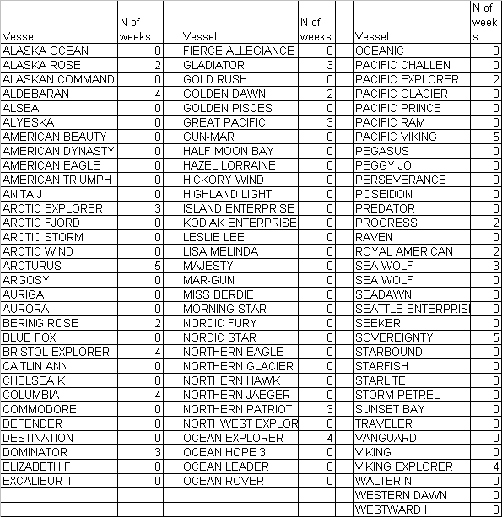

Number of weeks each vessel was on the chum dirty 20 list
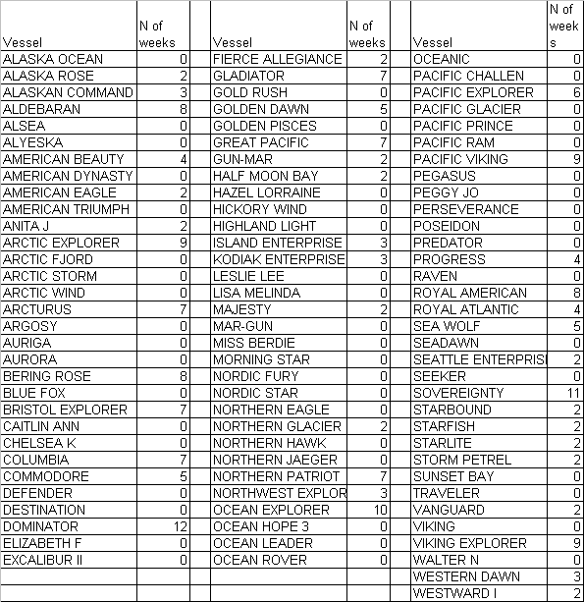

Appendix 1. Intercoop salmon closures, August 1 – October 31, 2006
